Tutorial 3 - SPM (wk 8 - done)

Question 1 (Team 1)
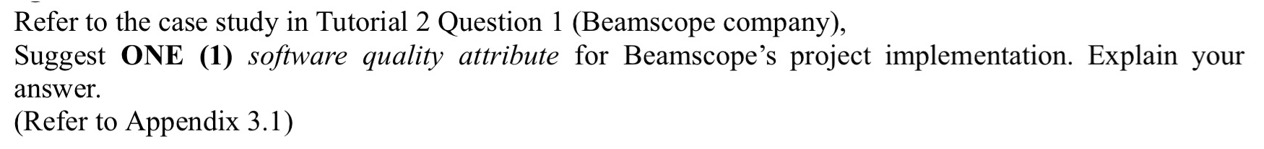

Suggested Software Quality Attribute: Performance (Efficiency)

Efficiency refers to the ability of the system to perform its functions quickly and with minimal use of system resources such as time, memory, or processing power. A highly efficient system responds promptly to user requests and processes large volumes of data or tasks without unnecessary delays.

Reason:
- To Reduce Order Processing Time
In the old system, it took 5 to 7 days to ship an order due to manual steps like handwriting orders, checking credit manually, and confirming stock by phone. This caused serious delays and customer dissatisfaction. So that, The new system should allow real-time order placement, instant inventory checking and automated processing. This dramatically improves speed, ensuring faster order fulfillment and a better customer experience.

- To Maximize Operational Productivity
Under the old manual system, staff had to spend a significant amount of time on repetitive and low-value tasks such as searching for inventory, confirming orders by phone, and compiling paper-based reports. These processes not only slowed down operations but also increased the risk of human error. With the new system, many of these tasks are automated—inventory is tracked using bar-code and radio frequency technology, order data is centralized, and reports are generated in real time. This reduces manual workload, minimizes errors, and allows employees to focus on more strategic tasks, ultimately increasing the company’s overall efficiency and capacity to handle larger volumes of business with fewer resources.

Question 2

Team 2
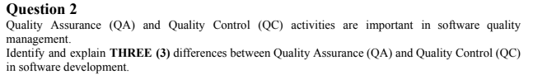
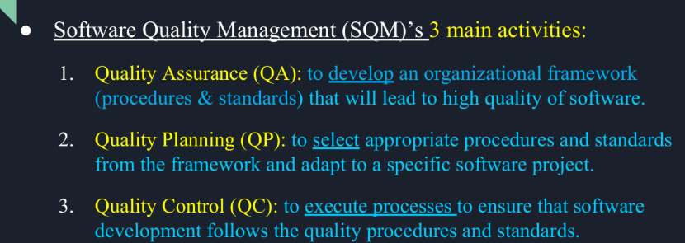

Aspect | Quality Assurance (QA) | Quality Control (QC) | Example
Focus | QA focuses on preventing defects by improving development processes and standards. | QC focuses on detecting defects in the actual software product through testing. | QA : Implementing coding standards to avoid bugs.  QC : Running unit tests to find bugs.
Approach and Timing | QA is proactive and done throughout the software development lifecycle | QC is reactive and done after the product is developed (during or after testing) | QA : Conducting process audits during development.  QC : Performing system testing before release.
Responsibility | QA is the responsibility of all team members, especially those involved in the process. | QC is mainly the responsibility of the testing team or quality control engineers. | QA : A developer follows peer review practices  QC : Testers execute test cases to find bugs.

Question 3
Team 3
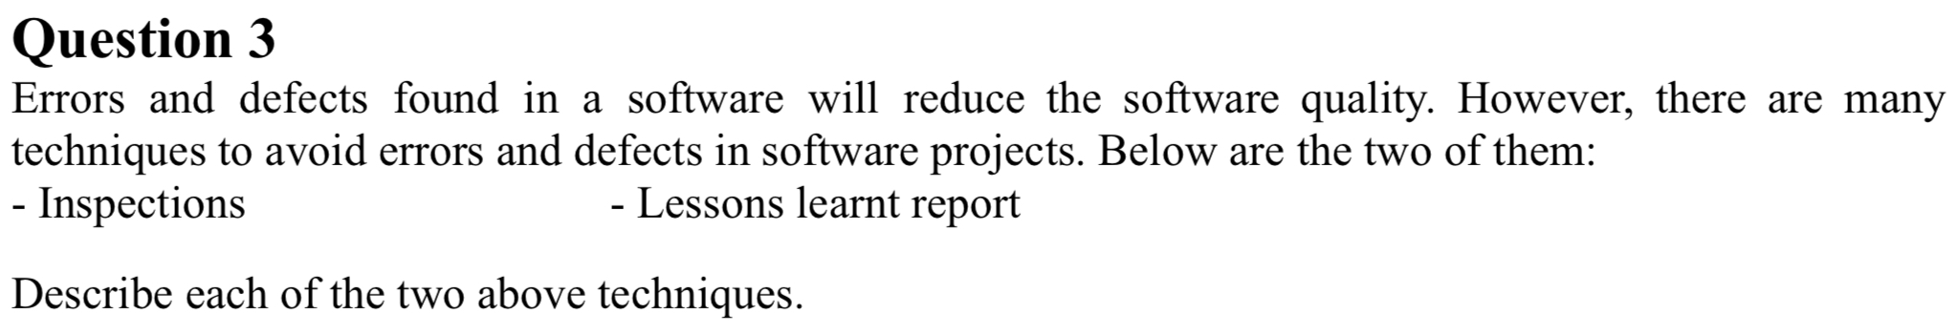

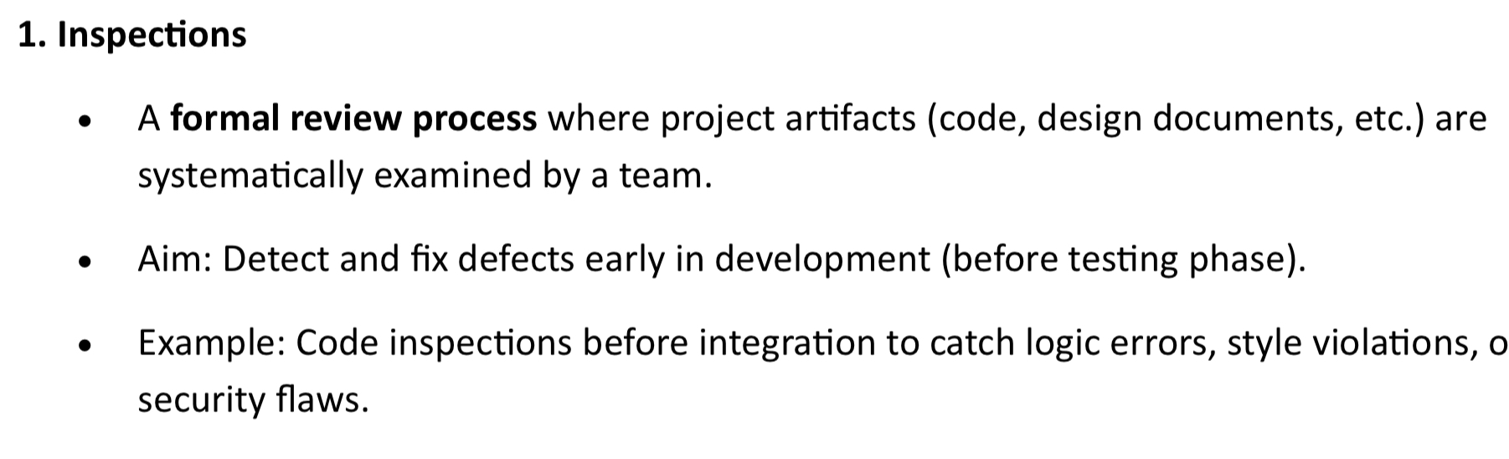
- refer slide pg30

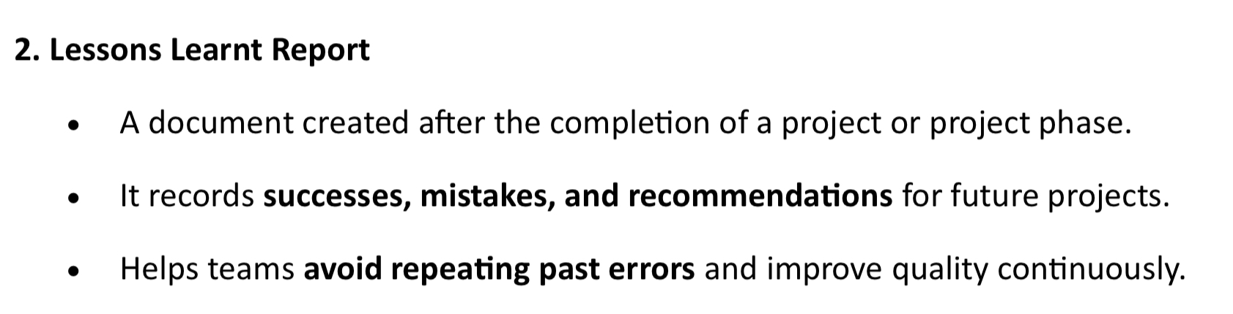
- records What when well
- Created by project manager

**Q3 add in gantt chart

Question 4
The president of ABC College has recently assigned you to manage a new project that is to develop an Access Card Control System for enhancing the security in the campus. For implementing this system, the quality of the software is as important as the quality of hardware such as RFID devices. In order to produce good quality software, it is necessary to perform quality management activities. However, performing quality management activities will incur costs.
Describe 3 categories of quality costs as given below:
- Prevention costs - Appraisal costs - Failure costs
Explain which category is likely to be most costly to the ABC College. Justify your answer.
Answer:
Prevention costs | Appraisal costs (Checking) | Failure Costs
1The cost of management activities - to plan and coordinate all Quality assurance(QA) and Quality control(QC) | The cost of conducting technical reviews. | Internal failure costs  - Costs to correct design error  - Cost to correct program error  Internal failure cost is a cost incurred before product delivery
The cost of technical activities - to develop complete requirements and design models  Example: Training the employees to use Access Card Control System developed, to prevent errors of using in the future. | Cost of testing products.  - Designing new test cases.  - Setting up a testing environment.  - Carrying out new test executions | External failure costs  - Resolving customer complaints  - Handling product return and replacement  - Providing help line support  - Managing a poor reputation  This is the cost incurred after the product has been delivered to customers
Cost of collecting data and reporting inspection.
Collecting reports as a result of data.
Reporting the inspection for the closing criteria.
The goal is to ensure a project is error-free or within an acceptable range. | To ensure that a project is error-free or within an acceptable range. | To ensure the project is error-free, and the customer is satisfied with the solution provided

It is failure costs, if the Access Card Control System has defects after deployment such as allowing unauthorized access or failing to read RFID cards properly it could compromise campus security, damage the college’s reputation, and require urgent and costly repairs. Moreover, handling complaints and possibly replacing hardware or software components adds substantial cost.

Internal Failure cost could be unauthorized access or failing to read RFID cards properly. This could cause damage to the college’s reputation due to low quality security measures. In terms of External Failure Costs, it could be that clients requiring urgent and costly repairs to be done. This could add substantial cost by handling complaints, and possibly replacing hardware or software components.

